Face Conduct

Attendance without time wasting

Team 7 “MAXIE”

Shakhan Mukhammedali

Kereybayev Ersaiyn

Myrzabekova Khanzada

Aitenova Meiirzhan

Muratova Inabat

SDU 2014

Project description:

Face recognition Software for attendance. This software app can be used to automatically identify or verify individuals in institutions (or universities, colleges, offices and other places) where the presence or attendance is to be controlled. It will shot an object and check by matching (with object in database).

Our goals:

* Automatize attendance checking using cameras.
* Patch attendance “holes” caused by humane factors
* Create comfortable interface to control students presence.

|  |
| --- |
| **actors**  - teachers, instructors(who checks the attendance) |
| -students  **use-cases:**  1. registration |
| 2. face-recognition |
| 3. information about individual |
| 4. attendance |
|  |

Login Page

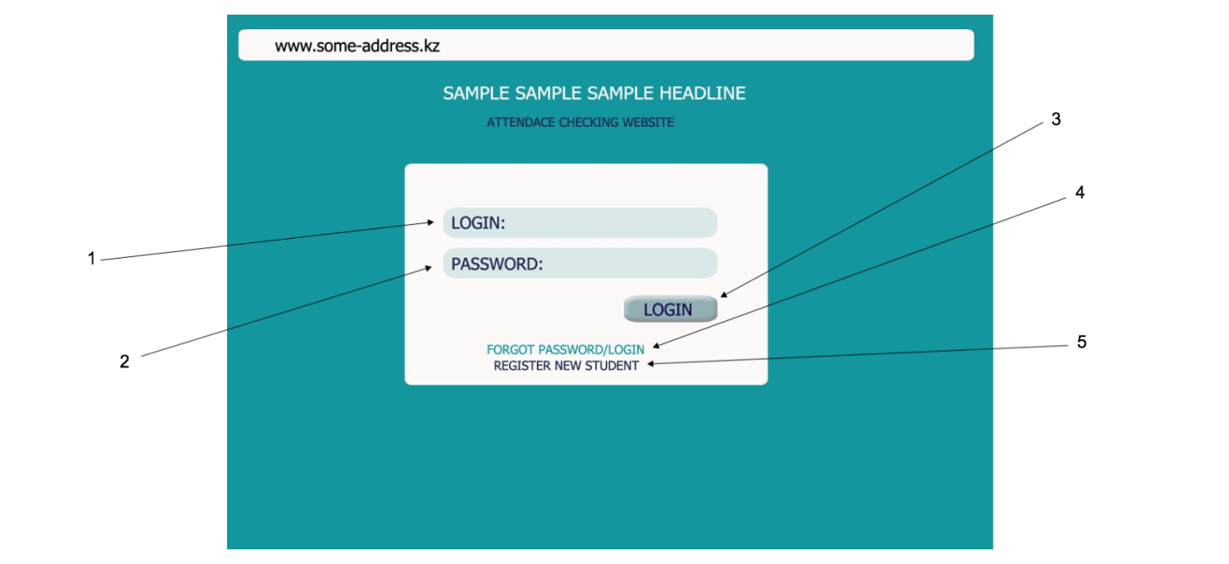

1. Login field
2. Password field
3. Login button
4. Password reminder by mail
5. Register new student

*By Muratova Inabat*

Register page

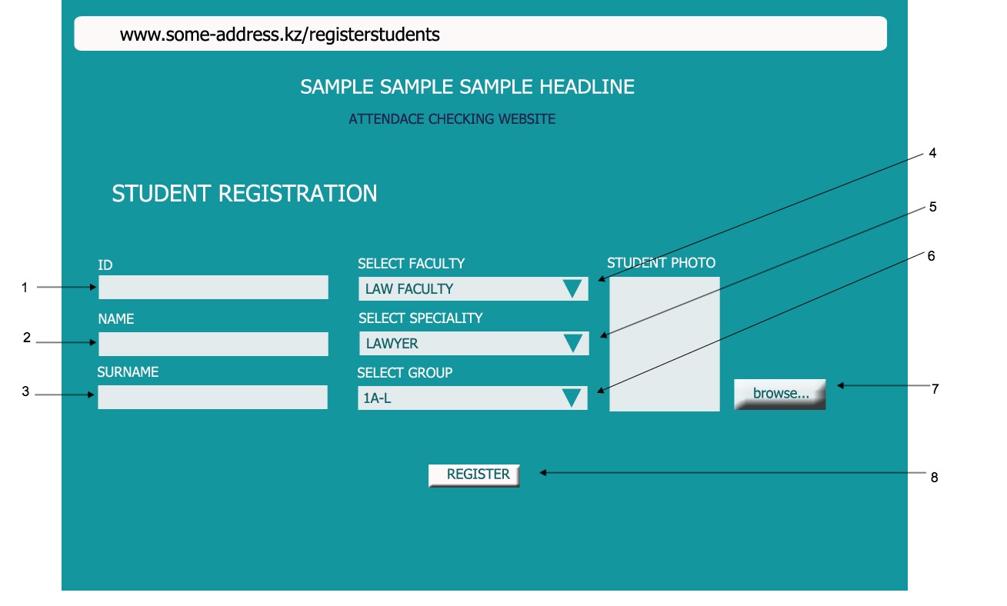

1. ID field
2. Name
3. Surname
4. Choosing faculty
5. Choosing specialty
6. Choosing group
7. Choosing image of student
8. Register button

*By Aitenova Meiirzhan*

Information about current user(who logged in)

1. Select faculty,speciality,subject,group to display needed attendance list.
2. Name of the group to be displayed
3. Filled in with”1” means following student attended at given date
4. Date
5. Total attended hours of following student
6. Button for modifying(editing) attendance table. Here you can add attendance hour to students
7. Sign out from current login

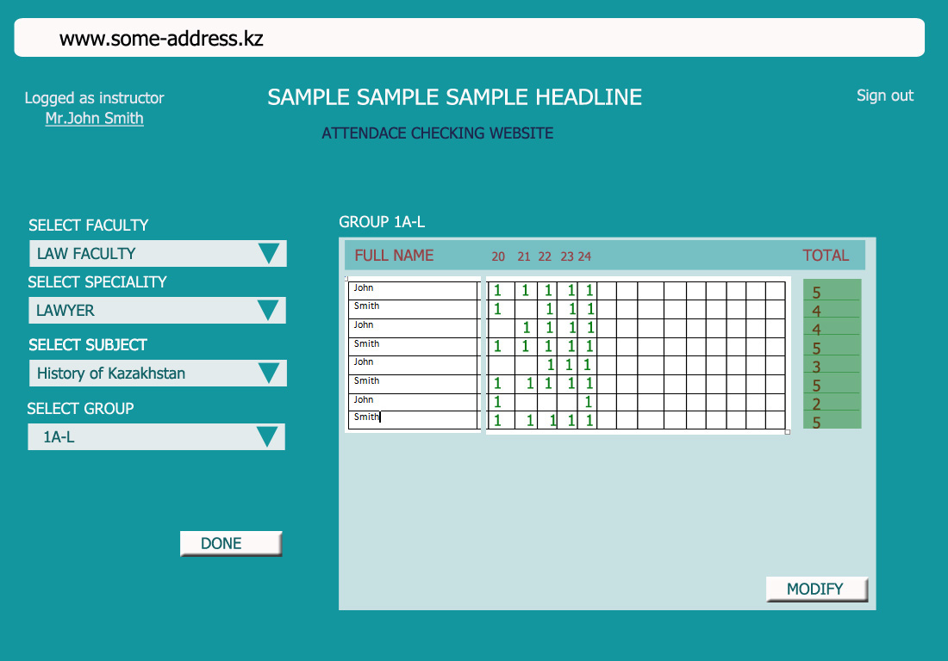

*By Myrzabekova Khanzada*

Camera display. Recognition field

1. Shot button
2. Information about recognized student
3. Photo of recognized student
4. Current time and date

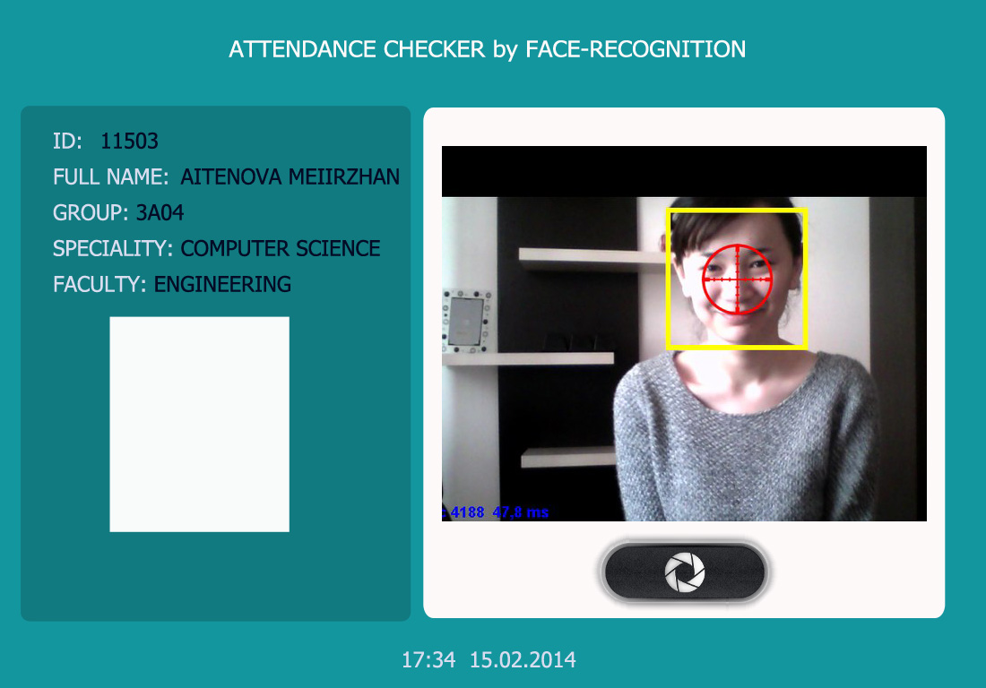

*By Shakhan Muhammed-Ali*

Modify page

1. Tables are editable. You may add or remove attendance point
2. Button to save edited information

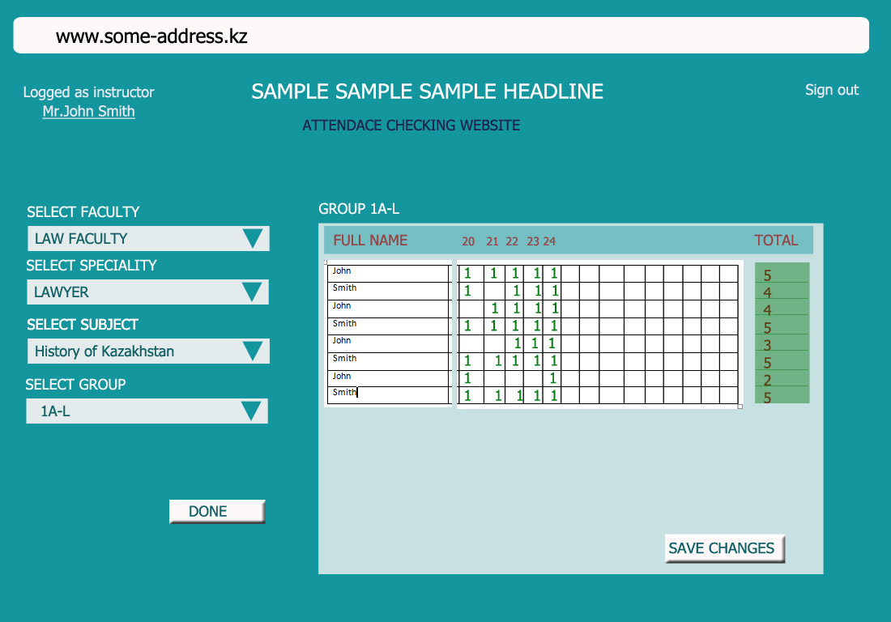

*By Kereybayev Yersaiyn*

